DPRC Connectome Pipeline

This pipeline is made to create a ‘connectome’ which will represent the connection between the white matter fibres to the grey matter regions. This will demonstrate the structural connectivity between the regions of the brain. Anatomically constrained tractography (ACT) and Spherical-deconvolution Informed Filtering (SIFT) will be utilised for generating the tracts.

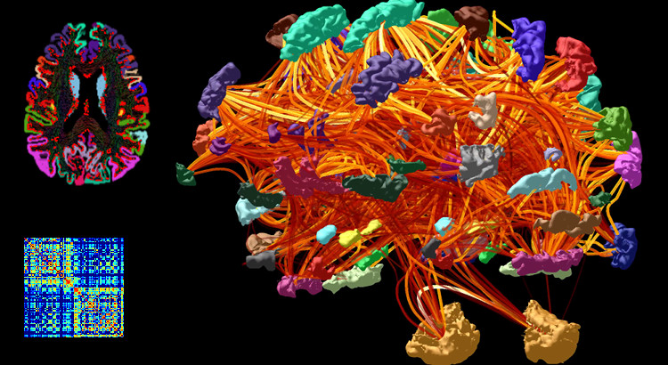

<https://mrtrix.readthedocs.io/en/latest/quantitative_structural_connectivity/structural_connectome.html>

Here are some other, good online free manuals on creating a connectome using MRtrix:

BATMAN: <https://osf.io/fkyht/>

Andrew Jahn’s brain book: <https://andysbrainbook.readthedocs.io/en/latest/MRtrix/MRtrix_Introduction.html>

Steps:

1. Create a 5tt image for ACT
   1. Perform bias field correction on t1w and t2 FLAIR images
   2. Co-registration t1w and t2 FLAIR to dwi image
   3. Generate a ‘4tt image’
   4. Edit in a pathological image to create a 5ttimage
   5. Create a ‘seed’ boundary between the white and grey matter for streamline generation
2. Create streamlines for tractography with ACT
3. Refine streamlines with SIFT
4. Parcellate brain regions/nodes with an atlas (e.g. FreeSurfer)
5. Create the connectome
   1. Convert labels to MRtrix format
   2. Co-register the parcellation to the grey matter boundary
   3. Create the whole-brain connectome
6. **Create a 5TT image for ACT**

We will create a 5 Tissue Type (5TT) image to use for the Anatomically-Constrained Tractography (ACT). By combining the t1w and t2 FLAIR images for brain segmentation, this will help to make anatomically and biologically plausible segmentations when generating the tractography. Four main steps (a, b, c, d) are carried out in order to do this. See the MRtrix ACT manual for more information: <https://mrtrix.readthedocs.io/en/latest/quantitative_structural_connectivity/act.html>

1. **Perform bias field correction on t1w and t2 FLAIR images**

Bias field correction should be done on the t1 and t2 images prior to inputting them into 5ttgen. Bias field correction is done by brain extraction (BET) and bias field correction (ANTs).

Command: bet (fsl)

N4BiasFieldCorrection (ANTs)

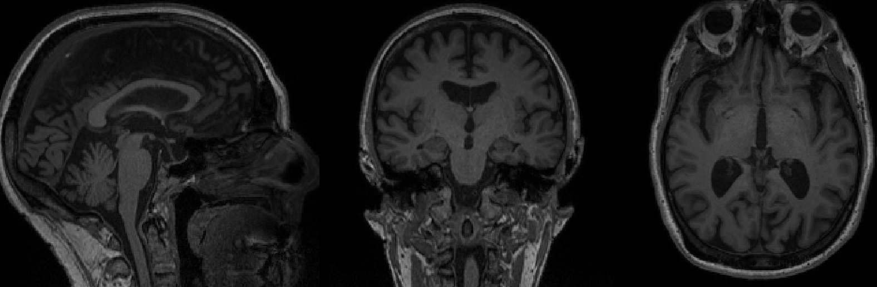

T1w anatomical, raw

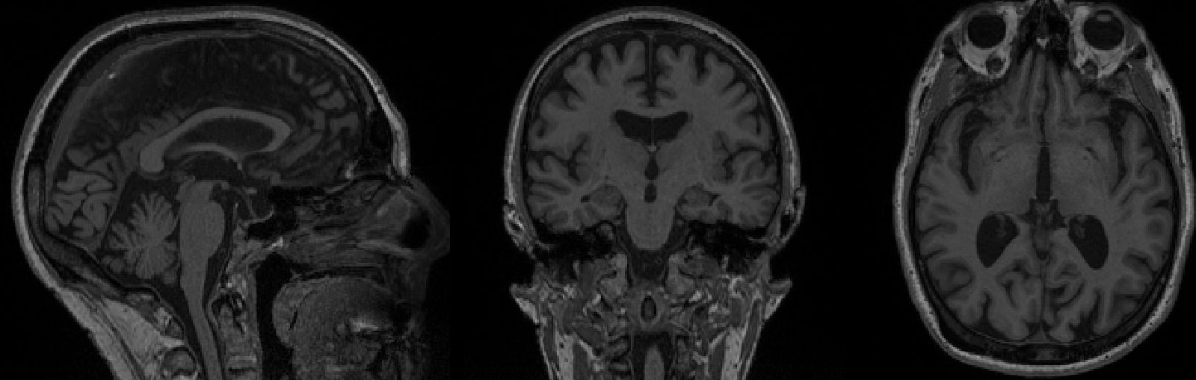

T1w anatomical, bias field corrected (you can see this better if you overlay on *fsleyes*).

Run bias field correction, using ANTs N4 algorithm: <https://community.mrtrix.org/t/t1-like-contrast-from-dwi-data/2782>

<https://community.mrtrix.org/t/preprocessing-questions/995/2>

1. **Co-registration of t1w and t2 FLAIR with dwi image**

Linear registration with 6 degrees of freedom (dof) are used. Do this registration with both the t1w and t2 FLAIR images to the dwi image (first b0 vol in dwi sequence - captured as the ‘bestb0’ from the previous script).

Command: flirt (fsl)

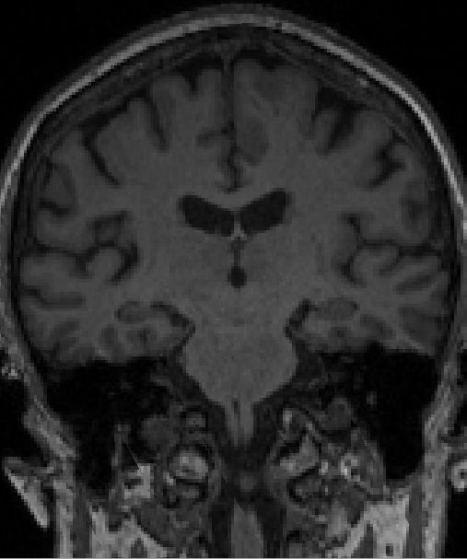 **+** 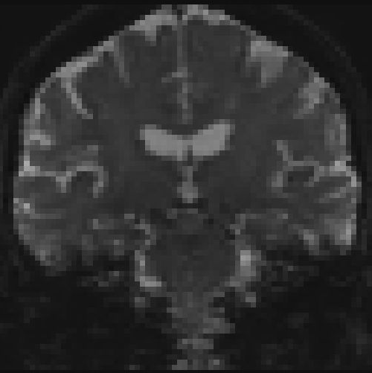

T1w dwi (b0)

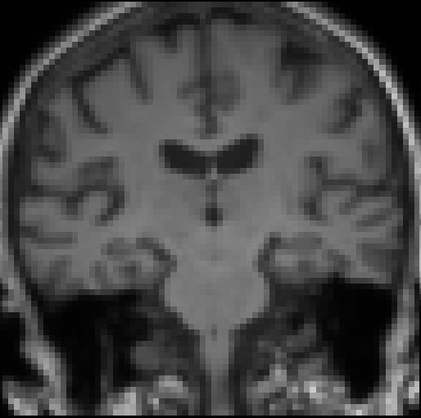

Co-registered (t1_flirt)

Once you have applied co-registration using FLIRT, you need to create linear transform matrices to apply to the images. This is because by default, FLIRT applies a direct *resampling* of the input image to match the target image, which is unnecessary. It is better to have flirt provide the calculated transformation matrix, then *apply* that linear transformation to the T1 image (either using flirt again, or combination of transformconvert and mrtransform), such that the image header transformation is altered but the image grid / intensities are not.

Command: transformconvert

mrtransform

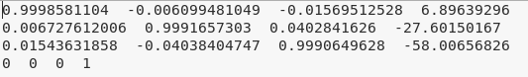

*transform_flirt_t12dwi.mat*

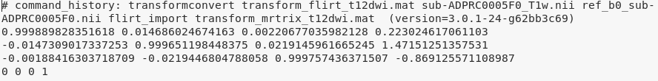

*transform_mrtrix_t12dwi.mat*

See posts on mrtrix community forum for more info: <https://community.mrtrix.org/t/5ttgen-error/1138>; <https://community.mrtrix.org/t/5ttgen-waiitng-for-creation-of-new-file/1044/2>

In addition, the provided T2 FLAIR image must be resampled to match the T1 image: <https://community.mrtrix.org/t/5ttgen-provided-t2-image-does-not-match-input-t1-image/1204>

Elapsed time: 59 sec

1. **Generate a ‘Five-Tissue-Type’ (but with 4 tissue types for now) image**

The 5 tissues include: cortical gm, subcortical gm, wm, csf, pathological tissue(*). Inputs to the 5ttgen include the t1w, t2 FLAIR image, the brain mask (generated from the preprocessing script), and the preprocessed/segmented t2 FLAIR (see below) as the pathological tissue. The 5ttgen script using the fsl algorithm interfaces with FSL to generate the necessary image data from the raw T1 and T2 FLAIR image, using BET, FAST and FIRST.

Command: 5ttgen -fsl

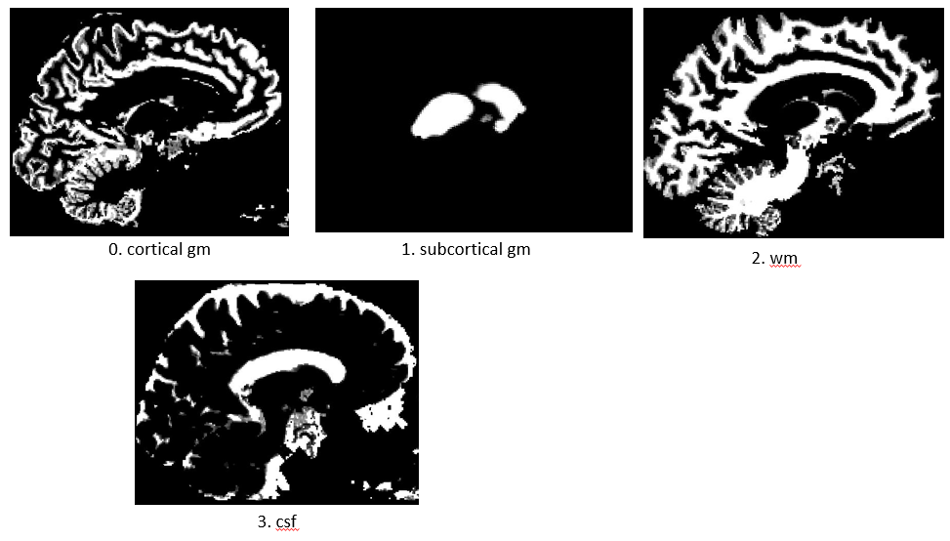

1. Cortical grey matter
2. Sub-cortical grey matter
3. White matter
4. CSF
5. Pathological tissue*

The highlighted white areas represent the specific tissue type.

Elapsed time: 12 min 52 sec

1. **Edit in a pathological image to create a 5ttimage**

*To add in the pathological tissue (in this case, with the white matter hyperintensities (WMHs) using the t2 FLAIR which is preprocessed and segmented with the lesions as a mask), you will need to edit and add in the image to the 5tt image. Using the toolbox Lesion Segmentation Tool (LST) under SPM, the lesion prediction algorithm (LPA) has done the preprocessing and segmentation of the WMHs. Match the pathological image to the 4ttimage on the same space (use mrtransform).

Command: 5ttedit

mrtransform

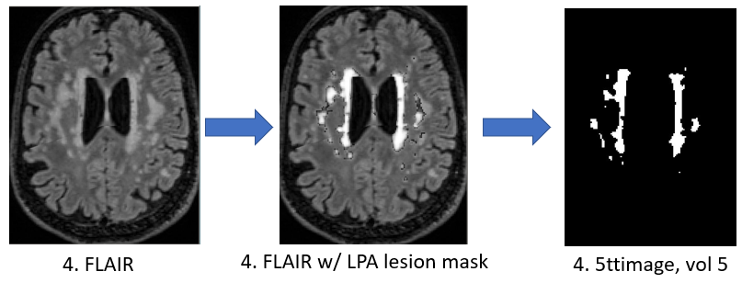

More information about dealing with WMHs from the MRtrix forum: <https://community.mrtrix.org/t/5ttgen-recommended-approach-to-dealing-with-white-matter-hyperintensities-wmhs-for-act/3753/3>

Maybe better to use 5ttgen -hsvs algorithm instead – combination of fsl and FreeSurfer tools. Hsvs = hybrid surface and volume segmentation.

<https://community.mrtrix.org/t/5ttgen-hsvs-template-option/3593/7>

Elapsed time: 2 sec

You can quickly and easily evaluate each 5tt image by running MRtrix’s 5ttcheck command; this will thoroughly check that the images conform to the expected ACT five-tissue-type (5TT) format. My script does this with the **FiveTTImageCheck.m** function, and the output is a text file (5ttImageCheck.txt), which displays the status of the 5tt image for all participants.

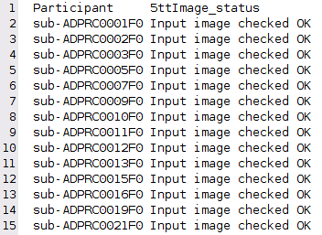

Elapsed time: 15 sec for 36 participants

1. **Create a ‘seed’ boundary between the white and grey matter for streamline generation**

This will create a mask image for the boundary separating the grey from the white matter, which we will be appropriate for seeding streamlines for tckgen.

Command: 5ttgmwmi

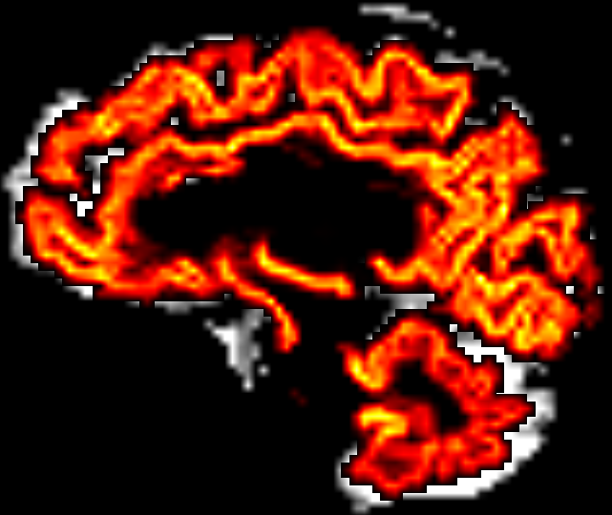

The ‘seed boundary’ mask, separating the grey from the white matter, overlayed on top of the 5tt image, with the grey matter segmentation (vol 0).

Elapsed time: 1 sec

1. **Generate streamlines for tractography with ACT**
2. Create the streamlines with all of the created boundaries and images which were done in the previous steps. Use the -act and -seed_gmwmi options. The anatomically constrained tractography (ACT) option to input in the different tissue types of the brain to generate more biological plausible orientations (by using the 5tt image that we generated in the previous steps). It is also recommended to NOT provide a brain mask if you are using the 5TT image as input for ACT. The -backtrack option will resample rejected streamlines from a defined number of steps back.

Command: tckgen -act -backtrack -seed_gmwmi

Some additional options are inputting the ‘seed boundary’ between grey matter and white matter image that we created in the previous step, and the -backtrack option, which indicates for the current streamline to go back and run the same streamline again if it terminates in a strange place (e.g. in the CSF).

Elapsed time: 2 hours and 22 min

You won’t be able to see the .tck file if you generated a large amount of streamlines (e.g. 10 million). So, if you wanted to view them, make a smaller version.

Command: tckedit -number 200k

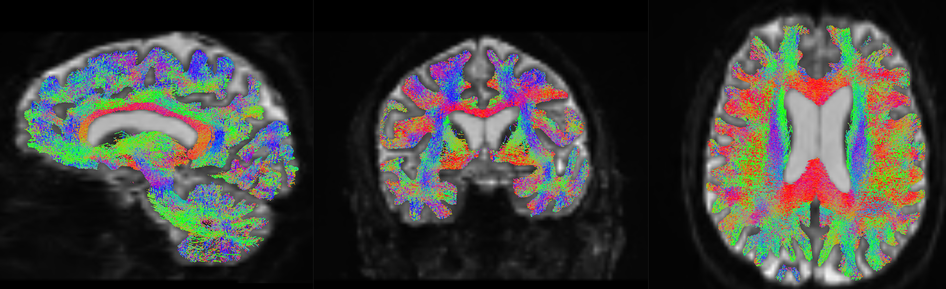

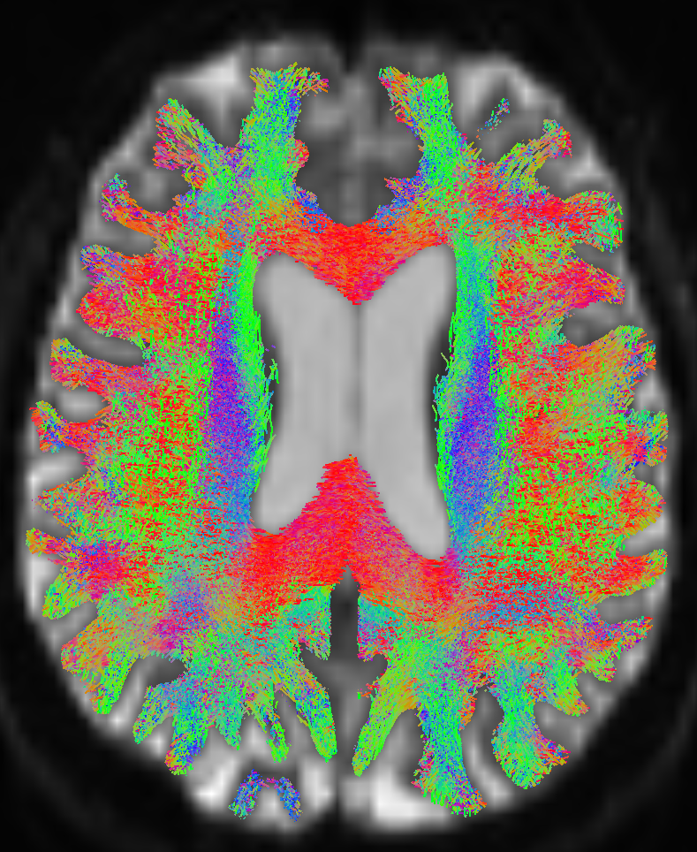

Result of streamline generation by ACT which is displayed as an overlay on the DW image. The tracks are colour-coded – red indicates streamlines from right to left, green from anterior to posterior, blue from superior to inferior. Note that the streamlines terminate reliably at the gray-matter/white-matter-boundary. This is a result of ACT.

*Smith et al., (2012). Anatomically-constrained tractography: Improved diffusion MRI streamlines tractography through effective use of anatomical information*

Elapsed time: 3 sec

1. **Refine streamlines with SIFT**

Like in the previous FBA script, we will need to perform the Spherical-deconvolution Informed Filtering of Tractograms (SIFT) to reduce tractography biases and overfitting which may contribute to false positives. This will help reduce tracts rom being overly-represented by the amount of streamlines that pass through them not necessarily because they contain more fibres, but because the fibres tend to all be orientated in the same direction. You should also pass the 5TT image to tcksift using the -act option. And again, you shouldn’t use a brain mask if you are using the 5TT image for the tissue constriction.

Command: tcksift2 -act

You can see the difference with SIFT if you view the tracts on a smaller scale, say with 10,000 tracts. Use tckedit to view this difference, like below:

**NO SIFT SIFT**

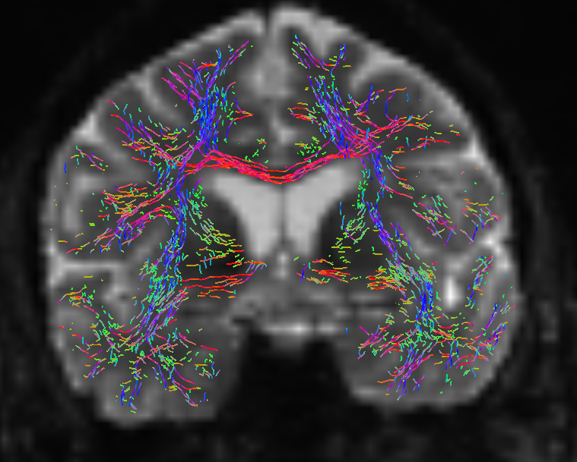 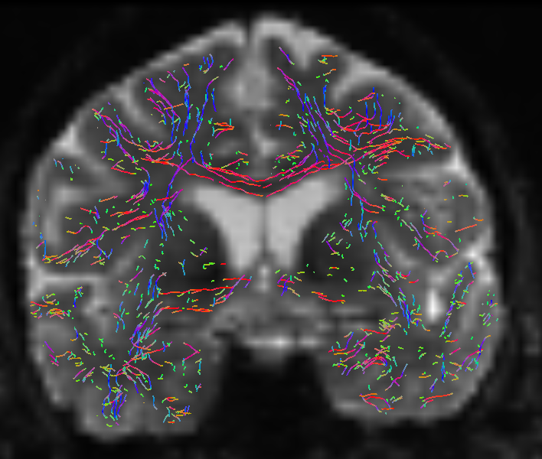

Result of using SIFT on the tracts. Both images are comprised with ten thousand (10k) tracks overlayed on the white matter DW image. Without SIFT, tracts such as the corpus callosum, are overestimated. SIFT corrects for this bias.

Elapsed time: 23 min

1. **Parcellate brain regions/nodes with an atlas (e.g. FreeSurfer)**

Now, we will parcellate the brain using the atlas on FreeSurfer, which assigns each voxel in the brain to a specific ROI. To do this, you will need to run each subject’s anatomical image though the FreeSurfer command, recon-all, which can take upt to a few hours per participant.

Within the DPRC dataset, much of this data has already been processed with the open-source **fmriprep pipeline** (<https://fmriprep.org/en/stable/>), and so we will actually be getting the preprocessed and segmented data from there (so no need to run the recon-all command if you will be doing this instead).

Command: recon-all (FreeSurfer command)

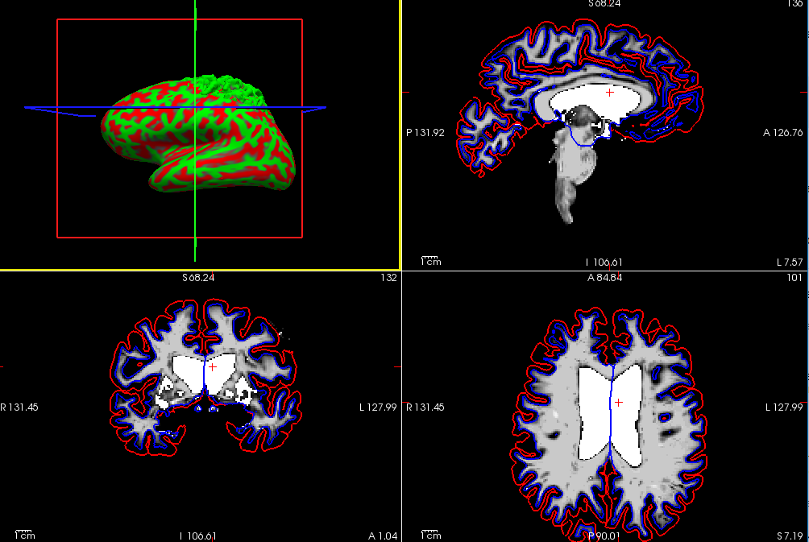

White matter volume segmentation (*wm.mgz*) shown in Freeview (FreeSurfer gui). Red is the pial outline and blue is the white matter outline. Inflation of the brain has been applied on the cortical surface (top left window).

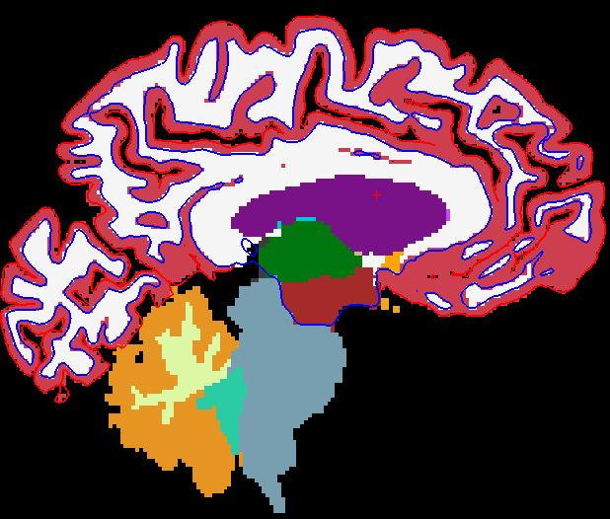 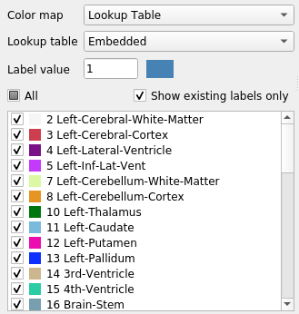

Segmented regions of the brain (*aseg.mgz*) as parcellated by FreeSurfer.

1. **Create the connectome**

Once we have the parcellations per each participant, we will now have to convert these labels to mrtrix format and create the whole brain connectome.

* 1. **Convert labels to MRtrix format**

We need to convert the labels of the used atlas (e.g. such as from FreeSurfer) into a format that MRtrix understands. This command takes an input parcellation image and converts the label indices; this is done so that the code that actually generates the connectome can be ‘dumb and blind’, i.e. the integer values at the streamline endpoints correspond to the row & column of the connectome matrix that should be incremented. The default FreeSurfer pipeline provides the volumetric image *aparc+aseg.mgz* (located in the subject/mri folder); this is the file that will be used to define the nodes of our connectome. This particular file will create an 84x84 matrix for our connectome – you can choose other atlases for a different number – see BATMAN tutorial for further information. You will also need to use FreeSurfer’s colour text file (FreeSurferColorLUT.txt), located in the FreeSurfer home directory:

Command: labelconvert

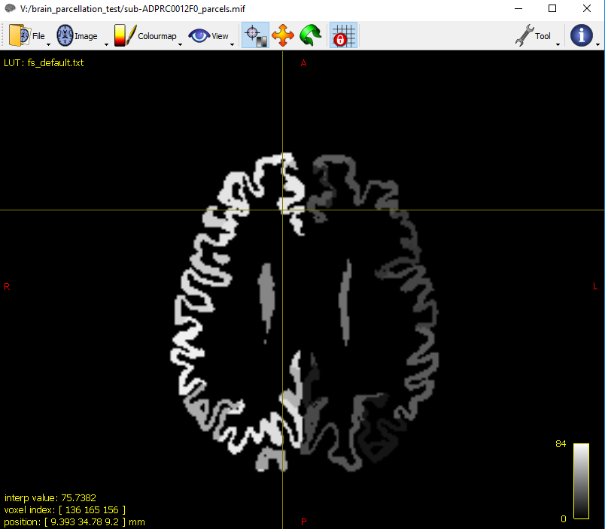

This is the parcellation image which has been converted to mrtrix formatting, with using the text files from both FreeSurfer and MRtrix.

labelconvert is a rather hard command to use / understand, and so there is a complete documentation with a provided example on this via mrtrix: <https://mrtrix.readthedocs.io/en/latest/quantitative_structural_connectivity/labelconvert_tutorial.html>

Elapsed time: 2 sec

* 1. **Co-register the parcellation to the grey matter boundary**

If you used mrtransform earlier to coregister the grey matter boundary, then you should use it again here to also coregister the parcellation.

Command: mrtransform

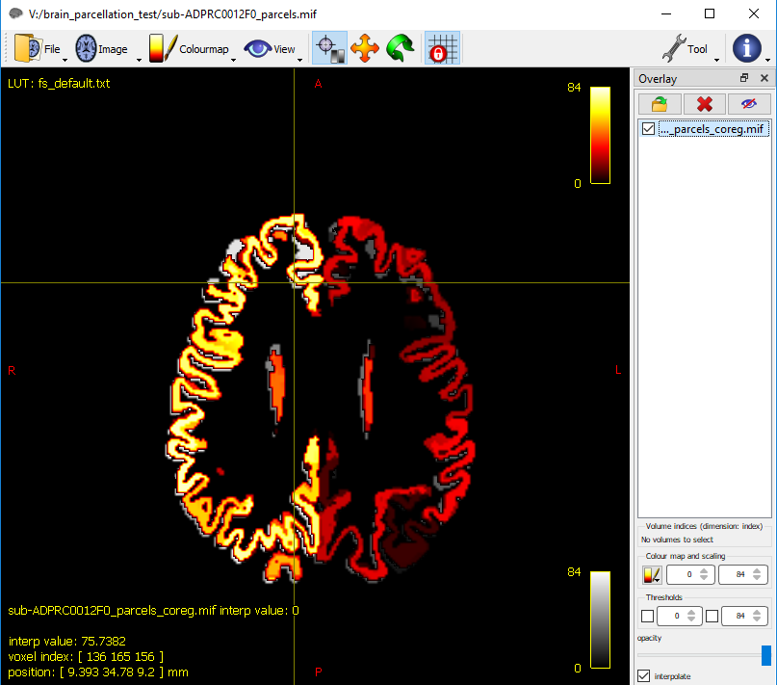

The coregistered parcellated image (in hot colours) overlayed on the parcellated image.

Elapsed time: < 1 sec

* 1. **Create the whole-brain connectome**

We will now generate the connectome through converting the tracts into a connectome matrix, based on the provided parcellated image. By default, the streamline count is used as the connectivity metric; run tck2connectome -help to see alternative heuristics / measures.

Command: tck2connectome

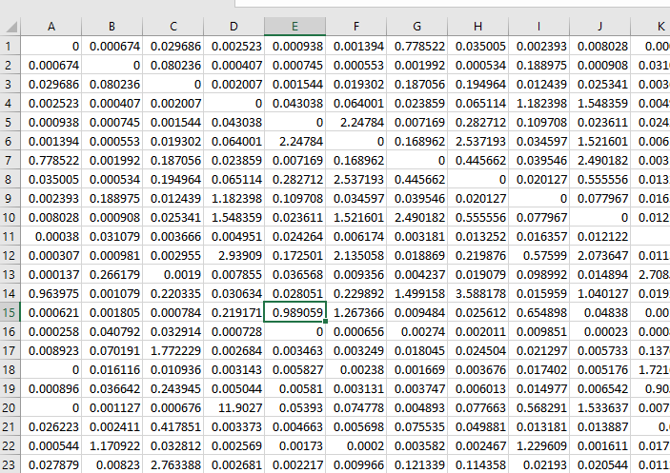 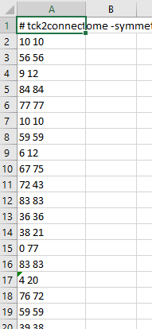

**_parcels_coreg.csv assignment_parcels_coreg.csv**

Elapsed time: 3 min

You can view the connectome matrix as an image through Matlab.

Command: connectome = importdata(matrix file.csv)

imagesc(connectome)



An 84x84 matrix representing the connectome. The two ‘boxes’ in the upper left and bottom right corners represent the structural connectivity within each hemisphere of the brain. Brighter smaller boxes represent increased structural connectivity between t the nodes. A noticeably, brighter diagonal line represents higher structural connectivity between nearby nodes.

To make the associations more obvious, you can change the colour scaling on the map:

Command: imagesc(connectome, [0 1]);





Here is another connectome matrix (379x379), which is based upon the human connectome project (HCP) atlas (Glasser et al., 2016). To use this atlas (the HCP MMP 1.0 atlas) for your data, you can follow the BATMAN tutorial.

References

Glasser, M.F., Coalson, T.S., Robinson, E.C., Hacker, C.D., Harwell, J., Yacoub, E., Ugurbil, K., Andersson, J., Beckmann, C.F., Jenkinson, M., Smith, S.M., Van Essen, D.C., 2016b. A multi-modal parcellation of human cerebral cortex. Nature 536, 171–178. https://doi.org/10.1038/nature18933

Smith, R. E., Tournier, J. D., Calamante, F., & Connelly, A. (2012). Anatomically-constrained tractography: Improved diffusion MRI streamlines tractography through effective use of anatomical information. NeuroImage, 62(3), 1924–1938. https://doi.org/10.1016/j.neuroimage.2012.06.005